**Keycode for array**

**Input array**

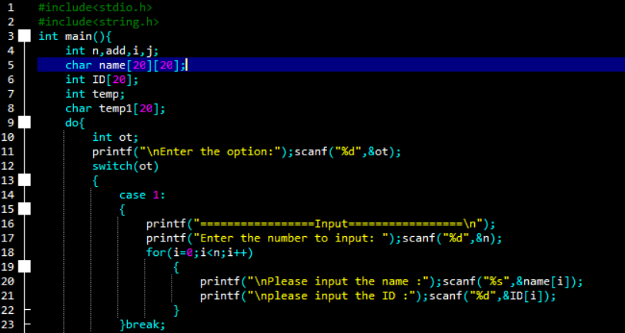

**Output array**

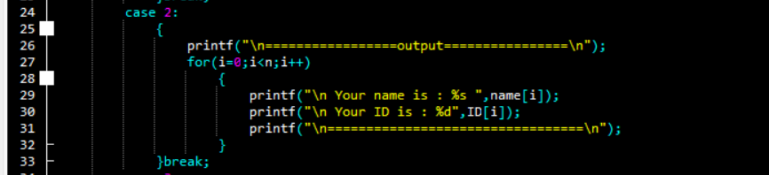

**Search array**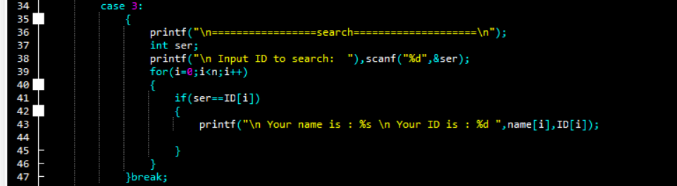

**Delete array**

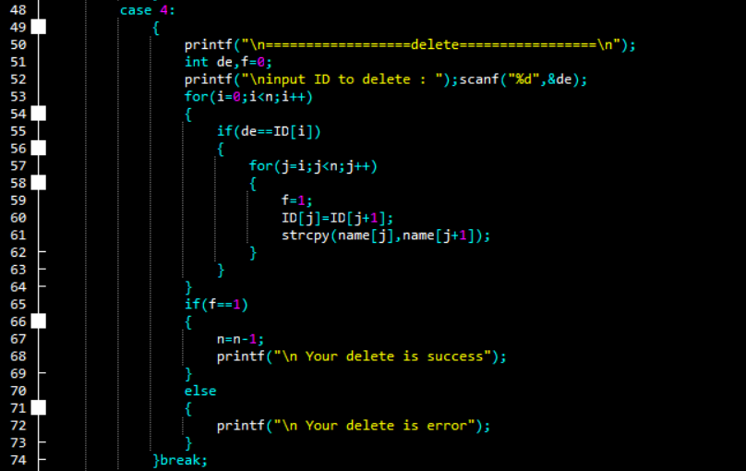

**Insert array**

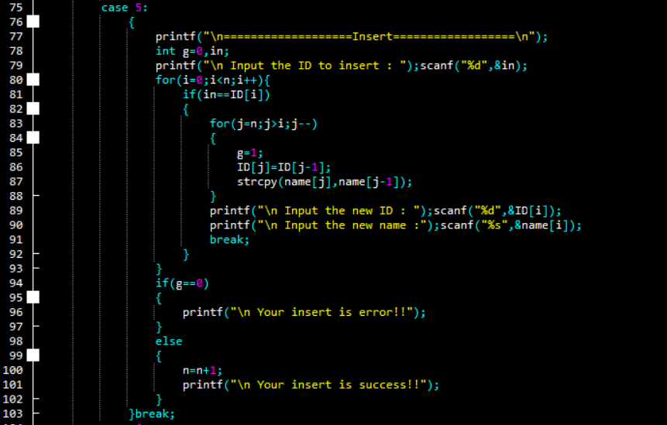

**Sort array**

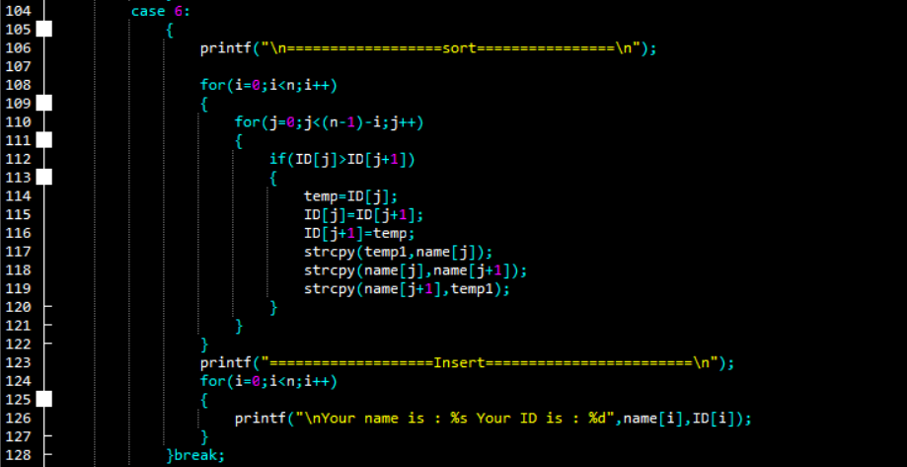

**Addition array**

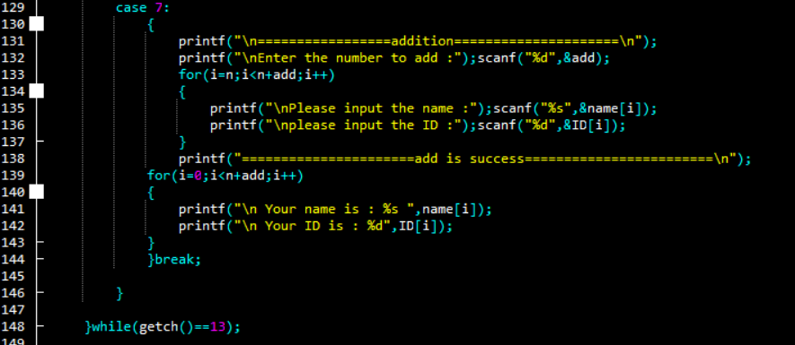

**Thanks for watching!**